How long does a viral respiratory tract infection usually last?
Colds usually get better in 7-10 days, and most coughs will have resolved by 3 weeks after the initial infection has passed

Infection Type | Usually lasts for:
Ear Infection | 4 days
Sore Throat | 1 week
Common Cold | 1 week
Sinusitis | 2 ½ weeks
Cough | 3 weeks

What else do I need to know?
- If your infection gets worse or lasts longer than expected you should see a doctor.
- For more information call Health line on 0800 611 116
- In an emergency call 111

When should you or your child see your doctor?
- If your temperature is above 38.5°C
- Shortness of breath, noisy or fast breathing
- Neck stiffness
- Severe headache
- Light hurting the eyes
- Chest pain
- Difficulty waking up or unusual drowsiness
- A skin rash
- Vomiting
- Persistent cough
- Aching muscles
- An existing condition is worsening

The Palms Medical Centre

Phone 06 354 7737

https://thedoctors.co.nz/the-palms

Coughs and Colds

Date of publication

This advice is for people who have an uncomplicated cough or cold caused by a virus.

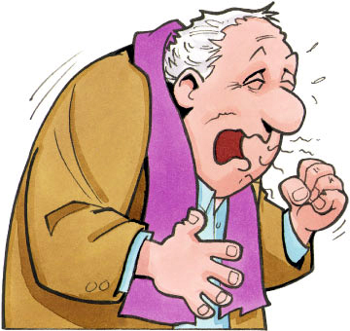

Colds are viral infections of the respiratory tract that cause symptoms such as sneezing, a blocked or runny nose, sinusitis, ear infections, a sore throat and coughing.

Antibiotics do NOT help with viral coughs, colds or flu

If you have a cold thought to be caused by a virus you should not be offered an antibiotic.

What can be done for coughs and colds?
- Drink plenty fluids and have plenty of rest
- Some medicines can help relieve the symptoms of a cold, ask your pharmacist for advice
- There is no robust evidence that vitamins, minerals or herbal medicines can treat colds, although zinc may reduce the severity and shorten the length of a cold for some people.

To relieve blocked or runny nose you can try:
- Salt water (saline) sprays or drops to clear mucus
- Inhale the steam from a running shower
- Decongestants to help relieve blocked noses

To relieve a sore throat or cough:
- Gargle warm salty water
- Suck ice or a throat lozenge

Stop the spread of colds by:
- Regularly washing your hands and ensuring anyone you have contact with also washes their hands
- to avoid spreading your cold to others
- Stay at home to avoid spreading your cold to others
- Cover your mouth and nose with a tissue or the inside of your elbow when you sneeze or cough – avoid using your hands for this
- Avoid touching the eyes, nose or mouth when unwell

What about the flu?
- The flu is caused by a different virus to a cold
- The flu tends to affect the whole body whereas a cold usually affects the nose and throat.
- A flu vaccine can prevent you getting the flu caused by the strains of virus in the vaccine but will not prevent you from getting colds.

Will antibiotics help a cold, flu or cough?
Colds, flu and most coughs are caused by viruses - antibiotics won’t help.

